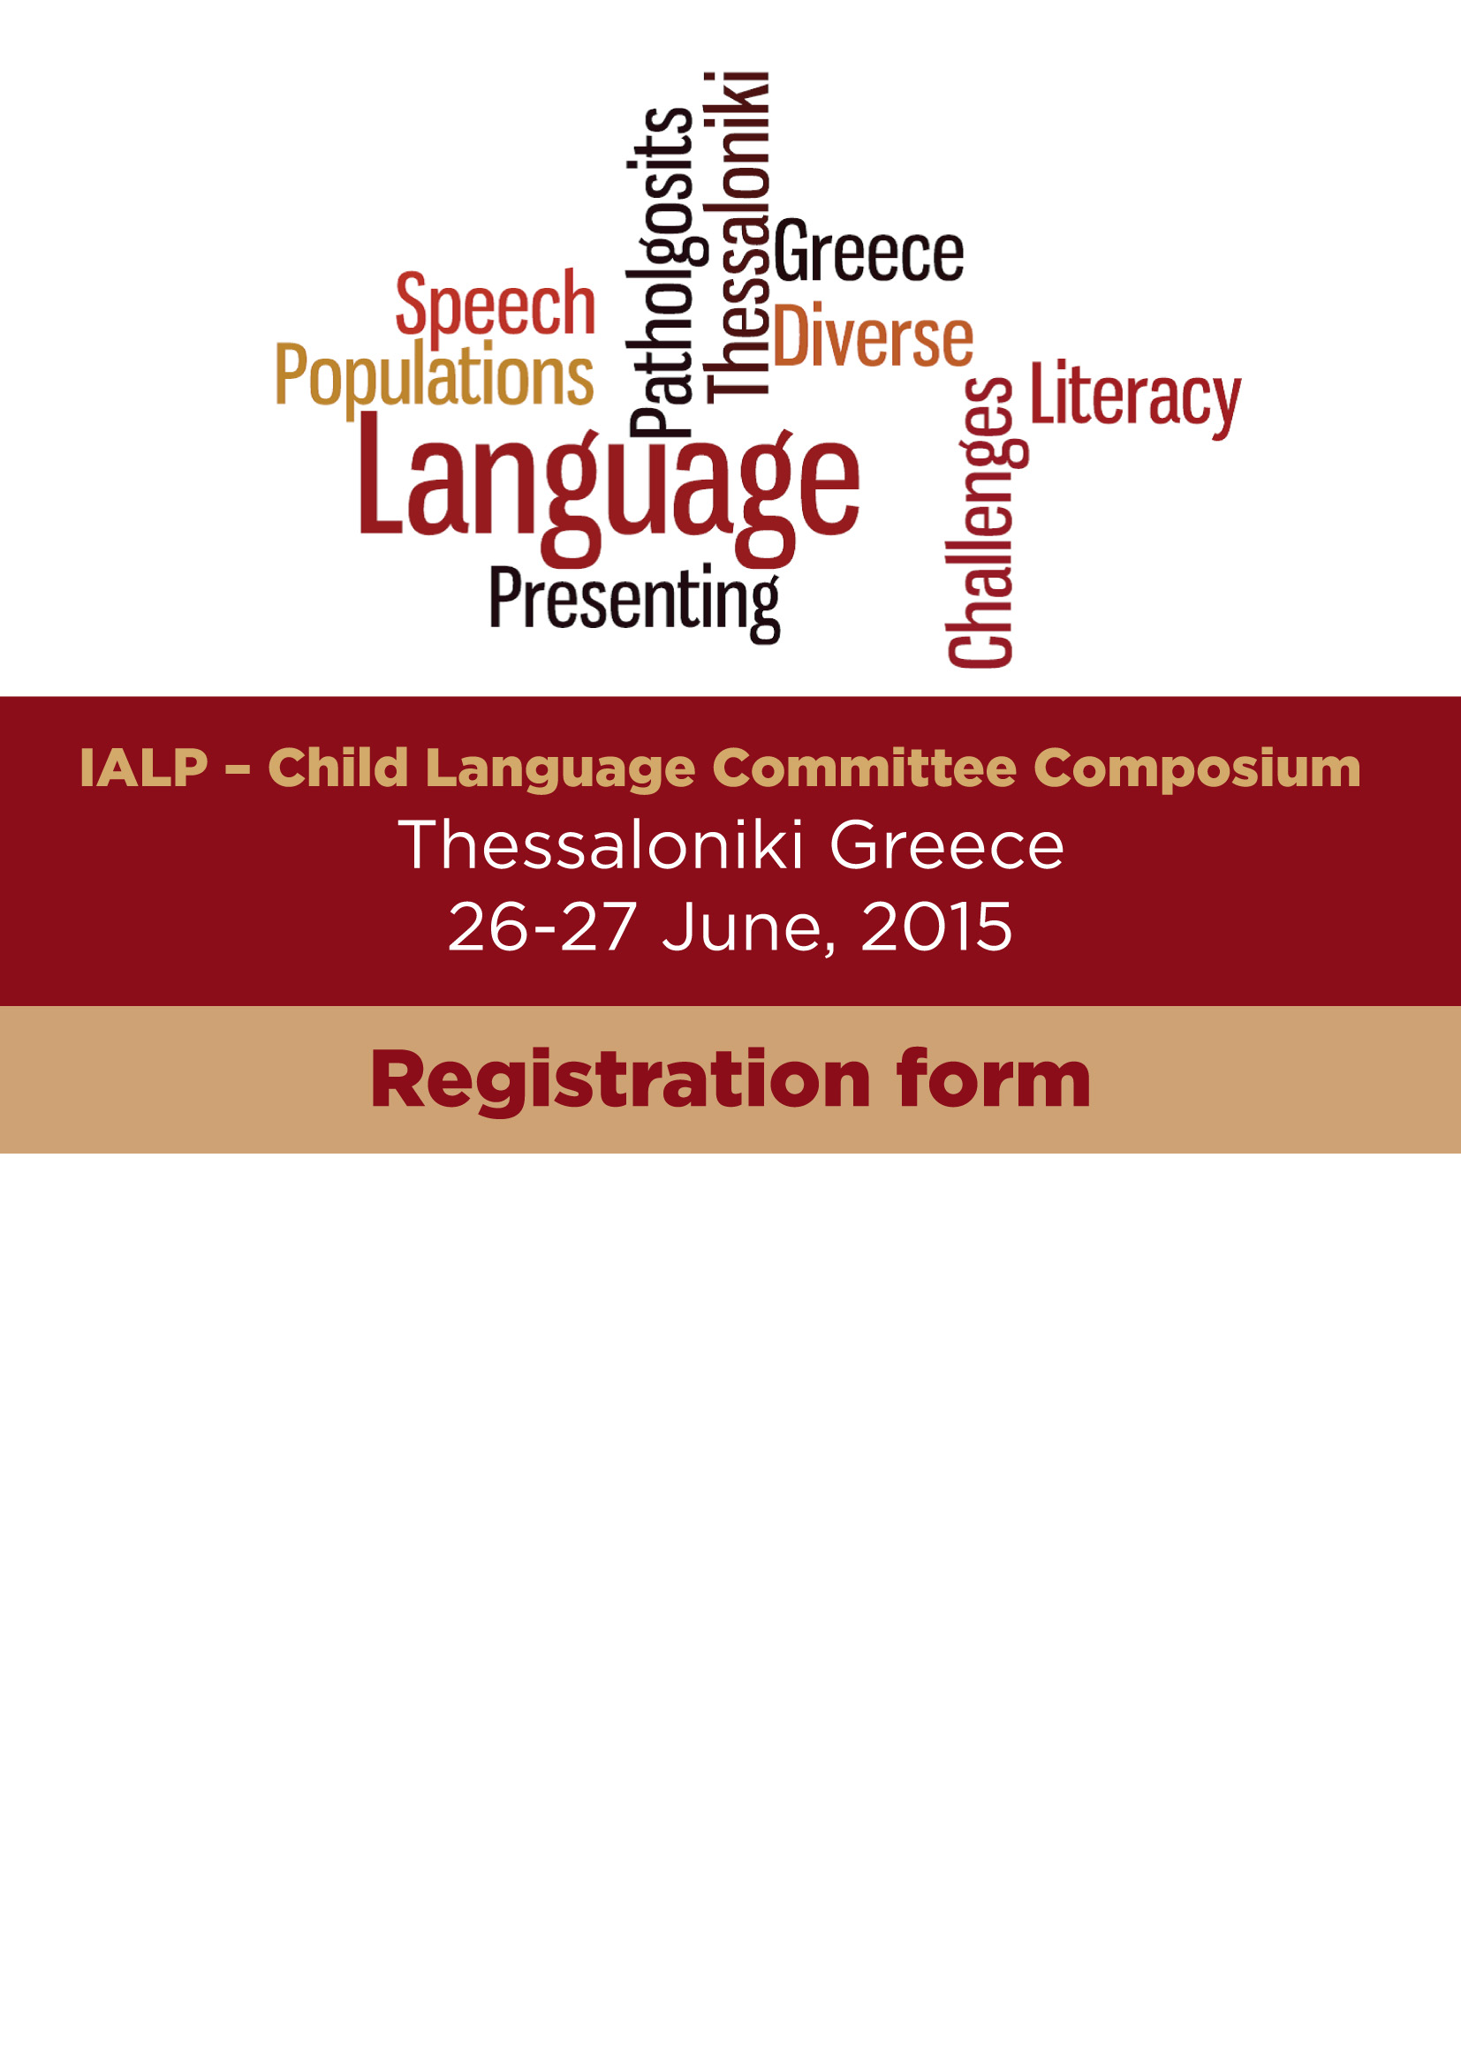

Name: Surname:

Address: Country:

Telephone: Fax:

Email:

FEES (enter your choice)
1. Early bird (ends 30 April 2015)
2. After May 1
- Attention: You may choose only two (2) workshops. The second workshop has an additional fee of 30/40€
- Please check the boxes of your choice below

- PROFESSIONALS’ FEE

I wish to attend: | Check your choice |  |  |  |  |  | Early bird April 30 2015 | After  May 1 2015
Τhe Composium & one workshop :  A , B , C , D , E , F |  |  |  |  |  |  | 100€ | 120€
Second Workshop:
Workshop A  Effective practices in phonological awareness to facilitate early reading and spelling success in children with speech disorder (Gail Gillon)  9.00 – 12.00 a.m |  |  |  |  |  |  | 30€* | 40€*
Workshop B  Introducing The Hanen It Takes Two to Talk Parent Training Program, Plus More (Yvette Hus)  9.00 – 12.00 a.m |  |  |  |  |  |  | 30€* | 40€*
Workshop C  Assessing Children’s Narrative Skills: Implications for Intervention (Carol Westby) 13.00 – 16.00 p.m. |  |  |  |  |  |  | 30€* | 40€*
Workshop D  Promoting speech intelligibility in preschoolers at risk for persistent language and literacy challenges (Kakia Petinou) 13.00 – 16.00 p.m. |  |  |  |  |  |  | 30€* | 40€*
Workshop E  Language Assessment for School Children (Ioannis Vogindroukas, Chelas Evripidis, Paparizos Konstantinos) 9.00 – 12.00 a.m |  |  |  |  |  |  | 30€* | 40€*
Workshop F  Intervention for Children’s Pragmatic Language Disorders (Tanya Gallagher) 13.00 – 16.00 p.m. |  |  |  |  |  |  | 30€* | 40€*
*additional fee for the second workshop

- STUDENTS’ FEE
I wish to attend: | Check your choice |  |  |  |  |  | Early bird  April 30 2015 | After  May 1 2015
Τhe Composium & one workshop :  A , B , C , D , E , F |  |  |  |  |  |  | 80€ | 100€
Workshop A  Effective practices in phonological awareness to facilitate early reading and spelling success in children with speech disorder (Gail Gillon)  9.00 – 12.00 a.m |  |  |  |  |  |  | 30€* | 40€*
Workshop B  Introducing The Hanen It Takes Two to Talk Parent Training Program, Plus More (Yvette Hus)  9.00 – 12.00 a.m |  |  |  |  |  |  | 30€* | 40€*
Workshop C  Assessing Children’s Narrative Skills: Implications for Intervention (Carol Westby) 13.00 – 16.00 p.m. |  |  |  |  |  |  | 30€* | 40€*
Workshop D  Promoting speech intelligibility in preschoolers at risk for persistent language and literacy challenges (Kakia Petinou) 13.00 – 16.00 p.m. |  |  |  |  |  |  | 30€* | 40€*
Workshop E  Language Assessment for School Children (Ioannis Vogindroukas, Chelas Evripidis, Paparizos Konstantinos) 9.00 – 12.00 a.m |  |  |  |  |  |  | 30€* | 40€*
Workshop F  Intervention for Children’s Pragmatic Language Disorders (Tanya Gallagher) 13.00 – 16.00 p.m. |  |  |  |  |  |  | 30€* | 40€*
*additional fee for the second workshop
Registration upon arrival Composium & one workshop: | Check Box | Fee
Registration upon arrival Composium & one workshop: |  | 140€

- Please complete the form and send it via e-mail to: kcharisi@epidirect.gr

- Payment by bank deposit (please note your name):
ALPHA BANK GR 33 0140 7080 7080 0232 000 2572, Leda Papadopoulou

